**1** An antitoxin is:

**A.** A virus that neutralises toxins.

**B.** A type of antibody

**C.** A chemical that cleans wounds.

**D.** A chemical that neutralises poisons. (1)

**2** Antibiotics were first discovered by:

**A.** Sir Edward Jenner

**B.** Sir Alexander Fleming

**C.** Edward Stone

**D.** Charles Darwin (1)

**3** A pathogen is a micro-organism that causes disease.

**a)** What are the four main disease causing pathogens? (4)

**b)** Flu is a communicable (infectious) disease. The disease cancer is non-communicable. Explain the difference between these two types of disease. (2)

**c)** The table below shows three diseases. Fill in the gaps to show the microbe or pathogen that causes the disease and how it is spread. (6)

|  |  |  |
| --- | --- | --- |
| Disease | Pathogen | How is it spread? |
| Measles |  |  |
| Malaria |  |  |
| *Chlamydia* |  |  |

**d)** What are the symptoms of athlete’s foot? (2)

**4** The body has several lines of defence to prevent infectious pathogens from attacking. The first line of defence is a barrier of some sort that stops pathogens entering the body.

**a)** How do the following act as barriers to infection?

**i)** lysozymes

**ii)** goblet cells and ciliated cells. (4)

**b)** The diagrams below show three stages from the body’s second line of defence.

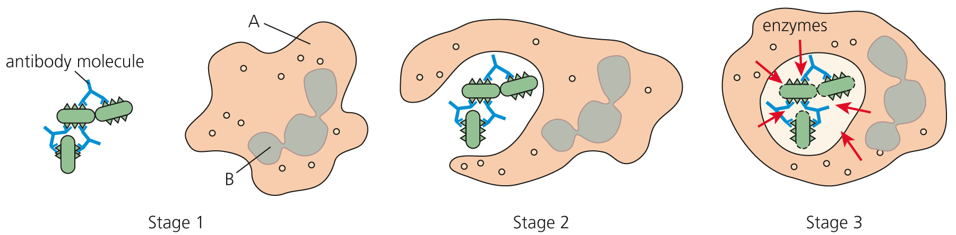

**i)** What type of cell is shown in the three stages? (1)

**ii)** Identify A and B from stage 1.

A =

B =

                               (2)

**iii)** Describe exactly what is happening in each of the three stages.

Stage 1:

Stage 2:

Stage 3:

(2 marks each = 6)

**5 a)** Fill in the gaps in the paragraph on vaccination using words from the list below.

A vaccination is a way of protecting people against ……… . Vaccinations work by stimulating the ……… system to produce antibodies. Vaccines contain ……… from a pathogen. This antigen is usually a very small quantity of dead, weak or ……… modified pathogen. The vaccine is injected into the body. The injection stimulates white blood cells called ……… to produce the correct antibodies. These antibodies remove the antigen from the body after a few days. ……… lymphocytes remember the antigen. If the real pathogen gets into the body, memory cells create even more antibodies and the ……… is rapidly removed. (7)

**lymphocytes  disease  memory  immune  antigen  pathogen  genetically**

**b)** The graph shows how the concentration of antibody in the blood changes in response to a vaccination. The first injection is given at point X. A second injection is given at point Y.

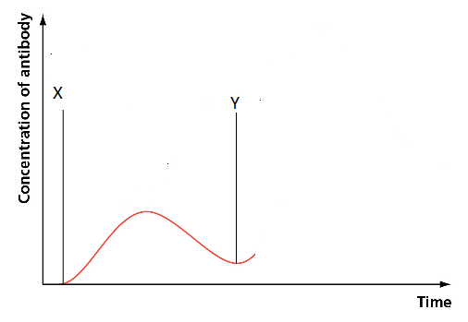

**i)** Complete the graph to show how the level of antibody changes after the second injection. (2)

**ii)** Explain the shape of the whole graph. (2)

**c)** What is meant by ‘herd immunity’ and why is it advantageous? (2)

**6 a)** What is the difference between an anaesthetic and an antibiotic? (2)

**b)** Modern drugs have to undergo many trials and tests before they can be prescribed. The process of trialling drugs is long and expensive. There are three main steps in drug trialling:

* computer modelling
* testing on animal cells and
* clinical trials on humans.

**i)** Why is it important that drugs are trialled carefully? (2)

**ii)** Some trials are double blinded and use placebos. Explain the double-blinded trial and the role of placebos. (4)

TOTAL = 50

**1** D (1)

**2** B (1)

**3** **a)** viruses, bacteria, fungi, protists (protozoa) (4)

**b)** A communicable diseases can be spread or passed from person to person; cancer is a disease that cannot be transmitted. (2)

**c)**

|  |  |  |
| --- | --- | --- |
| Disease | Pathogen | How spread |
| Measles | **Virus** | **In droplets/sneezing** |
| Malaria | **Protist** | **Mosquito bite** |
| *Chlamydia* | **Bacterium** | **Sexual contact** |

(6)

**d)** itching, flaking, blistering of skin; on foot/around the toes (2)

**4 a)** **i)** Lysozymes found in tears and saliva are antibacterial enzymes; they break down cell walls of bacteria. (2)

**ii)** Goblet cells produce mucus that traps pathogens; ciliated cells next to goblet cells waft the mucus and move the pathogens away. (2)

**b) i)** phagocyte (1)

**ii)** A = cytoplasm; B = (lobed) nucleus (2)

**iii)** Stage 1. Antibodies attach to pathogen(antigen); these are clumped together.

Stage 2. Phagocyte attracted to pathogens. Phagocyte engulfs/surrounds pathogens. Vacuole forms around pathogens.

Stage 3. Enzymes poured into vacuole. Pathogen is broken down/digested.

(2 marks maximum per stage = 6)

**5 a)** A vaccination is a way of protecting people against **disease**. Vaccinations work by stimulating the **immune** system to produce antibodies. Vaccines contain **antigen** from a pathogen. This antigen is usually a very small quantity of dead, weak or **genetically** modified pathogen. The vaccine is injected into the body. The injection stimulates white blood cells called **lymphocytes**  to produce the correct antibodies. These antibodies remove the antigen from the body after a few days. **Memory** lymphocytes remember the antigen. If the real pathogen gets into the body, memory cells create even more antibodies and the **pathogen** is rapidly removed. (7)

**b)** **i)** Line should be drawn steeper and higher. (2)

**ii)** Memory cells are made after the first injection.

The second injection of antigen stimulates these memory cells.

Memory cells remember the antigen.

More antibody is created.

Antibody is created faster. (2)

**c)** Herd immunity occurs when vast majority of people in a population have been vaccinated against a particular disease; even if a small number of people become infected, the disease is not likely to spread. (2)

**6** **a)** An anaesthetic is a drug that completely stops all pain.

An antibiotic is a chemical or drug; which occurs naturally; kills bacteria/stops bacteria reproducing. (2)

**b) i)** Drugs are dangerous; they have side effects; they may damage cells/tissues; they may not be effective. (2)

**ii)** Double-blinded trial:

* A patient is chosen at random.
* Patient may or may not receive the drug being tested.
* Doctors don’t know which patients are receiving the drug.
* Patients not receiving drug take a placebo.
* Placebo looks like a drug but has no active ingredient.
* People taking the placebo often feel better. (4)

TOTAL = 50